About

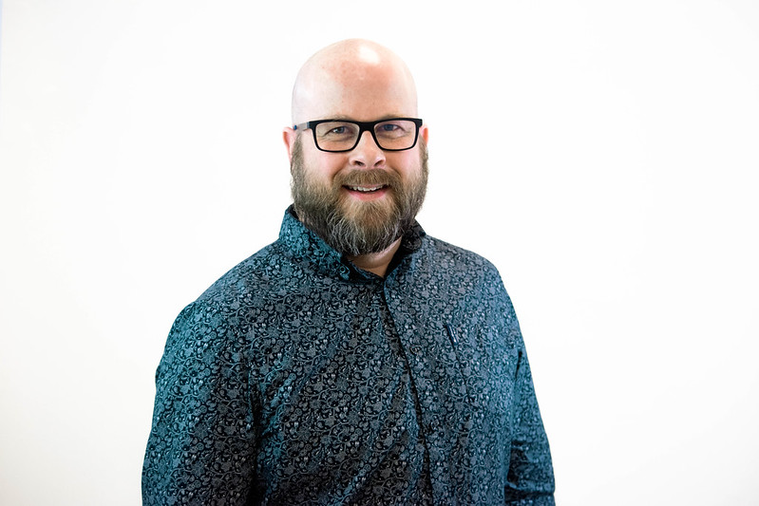

Colin M. Madland, PhD(c)

I am a Ph.D. candidate at the University of Victoria studying technology-integrated assessment in higher education.